**P530/3 BIOLOGY**

You are provided with specimen K which has been freshly killed.

1. Cut off the wings, limbs and antennae at their base.

Turn the specimen such that the ventral side faces the wax of the dissecting dish.

Draw fully (Do not label).

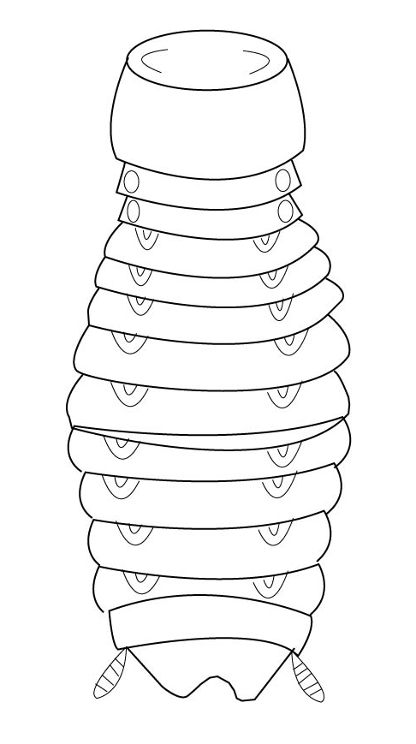Drawing showing the features on dorsal side of specimen K.

D-05

M-0

T-0

O-0

T= 07

1. Now turn the specimen such that the dorsal side faces the wax of the dissecting dish. Observe the posterior end of the abdomen.

Giving reasons, suggest the significance of the characteristic features

Sex Identification, swollen, podical plates; to accommodate the eggs; opening of ortheca; to allow for the passage of eggs; black abdominal end; to accommodate the eggs; Anal style with sensory hairs; for increased sensitivity during copulation; Narrow abdominal end; because of no eggs.

Pin the specimen and dissect to release the dorsal cuticle. Pin this cuticle to the left side        of the specimen. Clear off any fat and any unnecessary tissue to display:

(i) All the parts of the alimentary canal and displaced to the side of your choice.

(ii) The structures associated with the inner surface of the abdominal cuticles.

Draw and label the structures displayed in (i) and (ii) on the same diagram

LABELED DRAWING SHOWING ALL PARTS OF THE ALIMENTARY CANAL DISPLACED TO ONE SIDE AND THE STRUCTURES ASSOCIATED WITH THE INNER SURFACES OF THE ABDOMINAL CUTICLES OF SPECIMEN K.

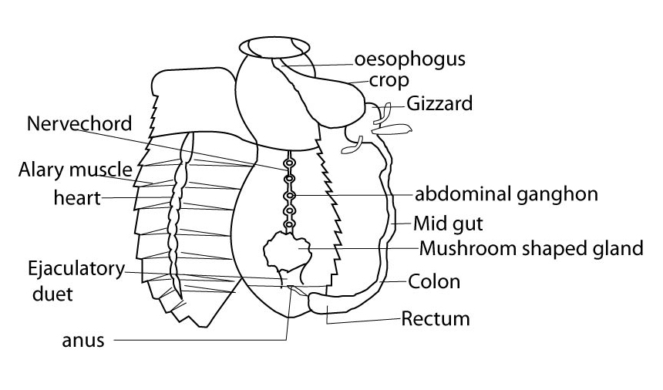

D-07

L-07

M-01

T-01

N-01

O-01

I-01

T=20mks

Qn2 Solutions A and B are both mixtures of common carbohydrates.

1. Using the chemicals and reagents provided, carry out tests to determine the composition of solution A and B.

Record your tests, observations and conclusions in the table 1 below:

|  |  |  |
| --- | --- | --- |
| TEST | OBSERVATION | CONCLUSION |
| REDUCING SUGAR  To 1cm3of solution  Add 1cm3 of Benedict’s  Solution and boil | A Turbid solution  turns to a blue solution, then to a green solution. | Trace  Reducing sugar present |
| B Turbid solution turns to a blue solution then to a green  Solution | Trace reducing sugars present |
| STARCH  To 1cm3of solution  Add 1cm3 of Iodine solution | A Turbid solution turns to a blue-black solution. | Much starch present |
| B Turbid solution turns to a brown solution | Starch absent |
| NON REDUCING SUGARS  To 1cm3 of solution+ 1cm3of HCL,boil,cool,+1cm3NaOH soln; then 1cm3 of Benedict’s soln,boil | A Turbid solution turns to a blue solution then to a green solution. | Non reducing sugars absent |
| B Turbid solution turns to blue-green. Yellow-orange ppt | Much Non reducing sugars. |

(17 marks)

**Comment on the abundance of the common nutrient in solutions A and B.**

1. Solution A has much starch; and Trace Reducing sugars;

Solution B has much Non reducing sugars; and Trace Reducing Sugars; (o4 marks)

1. Explain the difference (if any) in observations for reducing sugar and Non reducing sugar where solution A was used

Solution B Has no Non reducing sugars but trace Reducing sugars; (01 mark)

Because the same observation made for a reducing sugar test is observed for a non reducing sugar; so no hydrolysis;

(T=22 marks)

(b)Set up tubes 1-4 below to determine the solution containing an enzyme between solutions C and D: Incubate the contents of tubes 1- 4 in water bath maintained at 35-400C for 30 minutes. After this time, carry out Benedict’s test on contents of each tube.

Summary of the contents

|  |  |
| --- | --- |
| **Tube** | **Contents** |
| 1 | 2cm3 of A + 1cm3 of C |
| 2 | 2cm3 of A + 1cm3 of D |
| 3 | 2cm3 of B + 1cm3 of C |
| 4 | 2cm3 of B + 1cm3 of D |

Record your observations and conclusions in Table 2 below:-

|  |  |  |
| --- | --- | --- |
| TEST TUBE | OBSERVATION | CONCLUSION |
| 1 | Colourless solution  turns to blue solution  Then to green solution and to yellow precipitate. | Moderate reducing sugars present |
| 2. | Turbid Solution turns to a blue  Solution, then to a green solution | Trace reducing sugars present |
| 3. | Colourless/clear solution turns to a blue solution; then to green solution, yellow precipitate and orange precipitate | Much reducing sugars present. |
| 4 | Turbid solution turns to a blue solution, then to a green solution | Trace reducing sugars present. |

(13 marls)

1. Compare and explain the results for test tube pairs:

1 and 3

Test tube 1 has moderate R.S while test tube 3 has much R.S; because C contains enzyme(s);that catalyses the hydrolysis of the carbohydrates in A and B; but A is more complex carbohydrates; which is slowly hydrolysed; while B is less complex; and is rapidly hydrolyzed; (03 marks)

Test tubes 2 and 4

Test tubes 2 and 4 have trace R.S as before; so D has active substance/enzyme; and no hydrolysis occurs. (01 marks)

1. Name of active substance: (01 mark)

Amylase/invertase/ diastase;

Evidence: Catalyses the hydrolysis of starch/Non reducing sugar; (01 mark)

(T=42 marks)

Qn.3a Using a hand lens /low power magnification of the microscope, examine the external features of specimen R, S, T and U provided.

(i)For each specimen, state two structural characteristics used to place the specimen into its class.

Specimen S: 1. One pair of antennae;

2. Three main body divisions; accept any correct

characteristic) 02

Specimen T 1. Four pairs of legs;

2.Two main body divisions;(accept any correct                   characteristic)

02

(ii) Name the order to which the specimens

R-Dictyoptera

S-Diptera

T-Acarina

U- Isoptera 02

1. Mention three observable features used to classify the specimens into the same major group.

1. Segmented body;

2. Jointed appendages;

3. Exo skeleton

All must be features of arthropoda ` 03

B (i**) Differences**

R S

1. Unequal segments Even segments

2. Longer antennae shorter antennae

02

**Similarities**

1. Both are segmented;

2. Both are hairy

02

T=13

(ii) Drawing of the left antenna of specimen R Showing its attachment to the head.

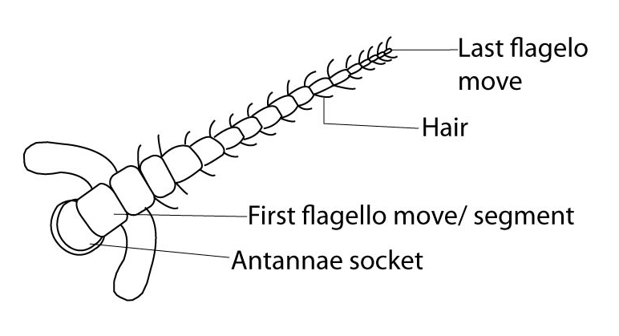

D-02

L-02

M-01

T-01

N-01

T=07

(iii) State the view from which the antenna was drawn.

Anterior view 01

(c) What three structural characteristics show that specimen T survives on a parasitic mode of           life?

(i) Claws for attachment on the host;

(ii) Sucking month parts for sucking blood;

(iii)Dorso-ventral flattering of the body to fit in the hairs; 03

T=10

1. Excluding structures from the head region, construct a dichotomous key to identify the specimens in the order R, S, T and ending with U.

(a) Many abdominal segments………………………….R

(b)Few abdominal segments……………………………2

2(a) Has wings……………………………………………S

(b)No wings…………………………………………….3

3(a) Has 8legs…………………………………………….T

(b)Has 6 legs…………………………………………….

I - 04

D - 0

O - 0 T = 05 (28 marks)